As a runner and as an officer of the Indiana Road Runners Club, the parks and trails created and maintained by Indiana County are very important to me and to my fellow club members. Our parks and trails provide us with beautiful natural areas where we can run, walk, and bike safely. Facilities in the parks and along the trails provide water and restrooms for those of us doing long training runs.

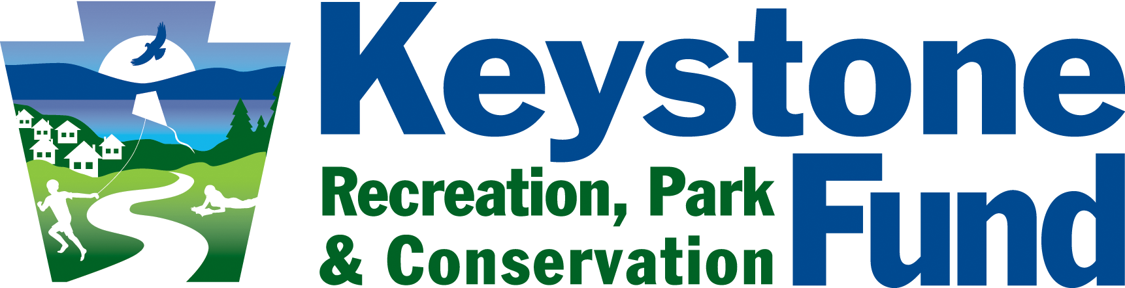

My Story

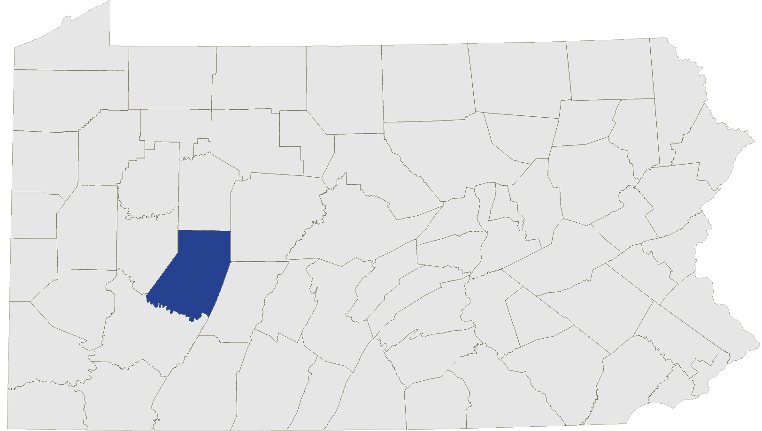

The Local Racecourse

Hoodlebug Trail

*By John Swauger, Runner*

***"Our parks and trails provide us with beautiful natural areas where we can run, walk, and bike safely."***

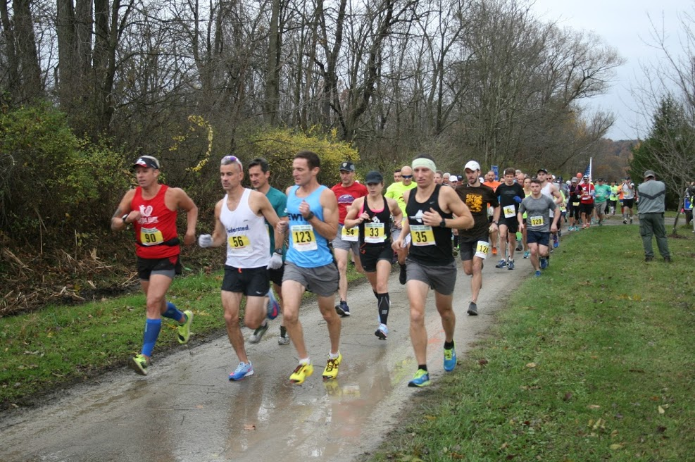

**Keystone Fund Investment:**  $224,000

**Local Funds Leveraged:**  $556,000

**Funded:** Trail and comfort station construction, utilities, signage, landscaping

The parks and trails are also used by many local and regional organizations to conduct races with race distances ranging from a 5K to the marathon distance of 26.2 miles. More than 25 races were held at the facilities of the Indiana County parks and trails in 2017. Many of those races were conducted as fundraisers for local charities.

The Indiana Road Runners Club uses portions of the Hoodlebug and Ghost Town Trails for three of its events, including the club’s premier event, the Indiana First Bank (IFB) Veteran’s Marathon, Half Marathon, and Marathon Relay. Over the past five years, a total of $75,000 has been raised at that race to benefit Indiana County Veterans. In 2017, more than 300 runners from 19 different states took part in the IFB Veteran’s races.